# Project Report - Online Automobile Magazine

## Background

Unlike a decade ago today consumers are experiencing novel sales processes due to seamless integration of online and offline business. Majority of automobile buyers, in fact almost 100% of used automobile buyers start their assessment and experience journey individually online; where dealers have now lost their role as the primary source of information as well as their influence over information shared. These customers use a wide range of online sources like automobile advertisement portals, dealer web sites, social media, blogs and forums to gather and compare information, moving the purchasing decision towards the online world.

Brief description

In this project we are going to implement a simple user-friendly system which enables automobile sellers to publish their advertisements online with detailed information; where automobile buyers can browse and look for available automobiles based on their requirements. Sellers need to pay to publish the advertisement; amount being charged will be based on the duration for the advertisement to be published online. Buyers can search for automobile advertisements without being charged. Neither sellers nor buyers need register to use the system. System admin can login to the system to manager advertisements and do necessary moderations.

Scope of the this project is limited to the extent where payment information are displayed with relevant use cases to demonstrate real business scenario, yet payment transactions are not handled though any real payment gateway.

Functional specifications

The system will be used by three different types of users. Each user shall use the system in different ways based on their objectives.

|  |  |  |
| --- | --- | --- |
| **User Type** | **Description** | **Use Cases** |
| Buyers | Users who are in search of information on automobiles available for buying. | * Search automobile advertisements published * View advertisement details |
| Sellers | Users who are in search of potential buyers for their automobile | * Submit automobile advertisement details to be published |
| System Admin | Content administrator for the system, who manages/ moderates automobile advertisements published/ requested to be published online | * Search published/ unpublished/ pending to be published automobile advertisements * View published/ unpublished/ pending to be published advertisement details * Publish/ Unpublished advertisements |

Buyer - Search automobile advertisements published

* Buyer shall access the system through URL; in the landing page itself there shall be two different sections which list down most recent advertisements and most viewed advertisements.
* Alternatively system shall provide menu item on top of the landing page for buyers to go to the advertisement listing page.
* Buyers shall filter the advertisements being listed based on their preference by search providing with necessary filter values. System shall support filtering based on model, brand and keywords.
* System shall provide pagination for advertisement listing if the result count is too high.

Buyer - View advertisement details

* Buyer shall come to the landing page and click on an advertisement link from top or most viewed advertisements sections. Buyer shall be taken to advertisement details page where system shall display fill information published regarding the automobile.
* Alternatively, buyer shall search advertisement based on filtering criteria from listings page, and click on one of the advertisements. Buyer shall be taken to advertisement details page where system shall display fill information published regarding the automobile.

Seller - Submit automobile advertisements to be published

* Seller shall land to the relevant section by clicking on the relevant menu from the top of the landing page.
* Seller shall enter below information in support of the advertisement.
  + Category (Brand New/ Registered)
  + Brand
  + Model
  + Year of Manufacture
  + Year of Registration
  + Options of the automobile (Ex:- Power Steering/ Power Mirror/ ABS)
  + Price
  + Location
  + Photos of the automobile
  + Contact Info
  + Additional Info
* Seller shall proceed to the next by clicking on next button.
* Seller shall enter desired duration for the advertisement to be published. System shall calculate and display the payment to be made based on duration.
* Seller shall click the submit button submit the advertisement. System admin shall verify the content and publish the advertisement through system.

System Admin - Search published/ unpublished/ pending to be published automobile advertisements

* System admin shall click on the administration link from the bottom of the landing page to go to the login page of the system.
* System admin shall login to the system using pre-defined user name and password
* System admin shall see and navigate the listings as buyers. Additionally system admin shall be able to view unpublished and pending to be published advertisements.

System Admin - View published/ unpublished/ pending to be published advertisement details

* System admin shall click on the administration link from the bottom of the landing page to go to the login page of the system.
* System admin shall login to the system using pre-defined user name and password.
* System admin shall see and navigate the listings as buyers. Additionally system admin shall be able to view unpublished and pending to be published advertisements.
* System admin shall click on any of the advertisements to go the detailed information page.

System Admin - Publish/ Unpublished advertisements

* System admin shall click on the administration link from the bottom of the landing page to go to the login page of the system.
* System admin shall login to the system using pre-defined user name and password.
* System admin shall see publish/ unpublished buttons against each advertisement in both listing and details view. System admin shall use publish/ unpublished buttons to publish/ unpublished advertisements.

## Database Information - ER Diagram

Advertisement

*Figure 1: ER Diagram*

## DATA MODEL DIAGRAM

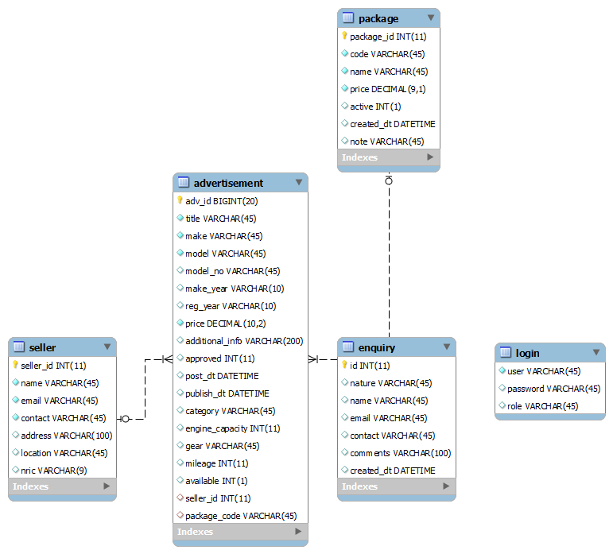

*Figure 2: Data Model Diagram*

## System Design

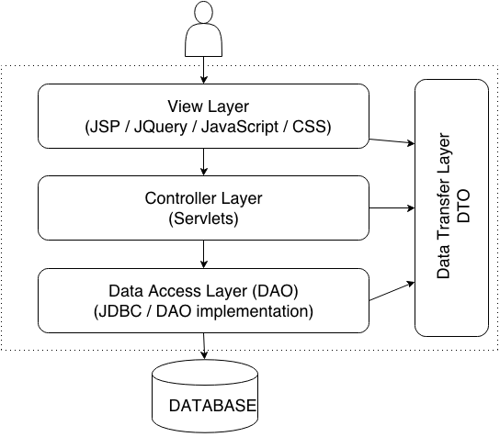

*Figure 3: High Level System Design*

## Application installation guidelines

Software & Hardware Configuration:

|  |  |  |  |
| --- | --- | --- | --- |
| **S.No** | **Software** | **Vendor** | **Version** |
| 1 | Java Development Kit (JDK) | Oracle | 1.6 |
| 2 | Tomcat App Server | Apache | 7.5 |
| 3 | Eclipse Luna | Eclipse | 3.6 |
| 4 | MySQL Database Server | Oracle | 5.5 |
| 5 | MySQL Workbench | Oracle | 6.1 |

|  |  |
| --- | --- |
| **S.No** | **Hardware** |
| 1 | Intel Pentium IV |
| 2 | RAM 2 GB |
| 3 | HDD 10 GB |
| 4 | Windows XP |

Installation Steps:

1. Create all database tables in mysql server by executing provided database dump script.
2. Import application war file in eclipse using import wizard.
3. Update DataSourceUtil.java with your MySQL root password.
4. Configure eclipse build path to sync tomcat class path to WEB-INF/classes folder.
5. Build imported project using clean tool on Project menu in eclipse.
6. Add project to Tomcat webapp directory using tomcat eclipse plugin.
7. Run the application after restarting the Tomcat server.

## Application usage guidelines

Usage guidelines have been documented and attached below.

